Practical No. 05

**Working with Navigation, Beautification and Master page.**

**Aim:**

1. **Create Web Form to demonstrate use of Website Navigation controls and Site Map.**
2. **Create a web application to demonstrate use of Master Page with applying Styles and Themes for page beautification.**
3. **Create a web application to demonstrate various states of ASP.NET Pages.**

**Name: Ankit Singh Chauhan**

**Roll No: 64**

**Class: T.Y.BSc.IT**

**Sub: Advanced Web Programming**

**Grade:**

**Sign:**

**Aim:**

**a.) Create Web Form to demonstrate use of Website Navigation controls and Site Map**

**Code:**

**Sitemap**

<?xml version="1.0" encoding="utf-8" ?>

<siteMap [xmlns="http://schemas.microsoft.com/AspNet/SiteMap-File-1.0"](http://schemas.microsoft.com/AspNet/SiteMap-File-1.0) >

<siteMapNode url="WebForm1.aspx" title="Home" description="">

<siteMapNode url="WebForm2.aspx" title="Second page" description="" />

<siteMapNode url="WebForm3.aspx" title="Third page" description="" />

</siteMapNode>

</siteMap>

**Webform1**

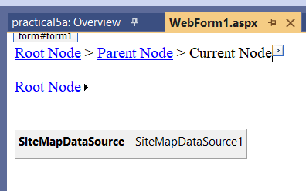

**Webform2**

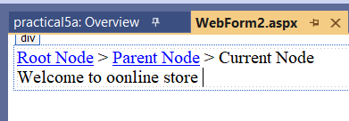

**Webform3**

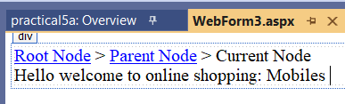

**Output:**

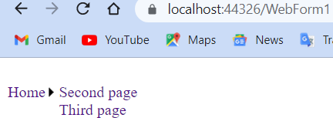

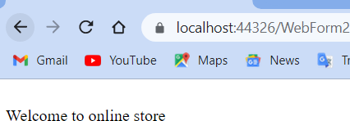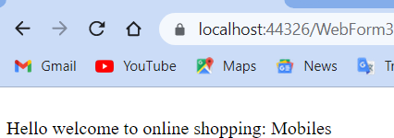

**Aim:**

**b. Create a web application to demonstrate use of Master Page with applying Styles and Themes for page beautification.**

**Code:**

**Webform 1**

<%@ Page Title="" Language="C#" MasterPageFile="~/Site1.Master" AutoEventWireup="true" CodeBehind="WebForm1.aspx.cs" Inherits="practical5b.WebForm1" Theme="Skin1"%>

<asp:Content ID="Content1" ContentPlaceHolderID="head" runat="server">

</asp:Content>

<asp:Content ID="Content2" ContentPlaceHolderID="ContentPlaceHolder1" runat="server">

<asp:Label ID="Label1" runat="server" SkinId= "lb1" Text="Select the date"></asp:Label>

<br />

<br />

<asp:Calendar ID="Calendar1" runat="server"></asp:Calendar>

<br />

<asp:HyperLink ID="HyperLink1" runat="server" NavigateUrl="~/WebForm2.aspx">Next</asp:HyperLink>

<br />

</asp:Content> **Stylesheet1.css** body {

background-color : gray; font: italic;

}

**Skin1.skin**

<asp:Label runat="server" SkinId="lb1" backcolor= blue/>

**Output:**

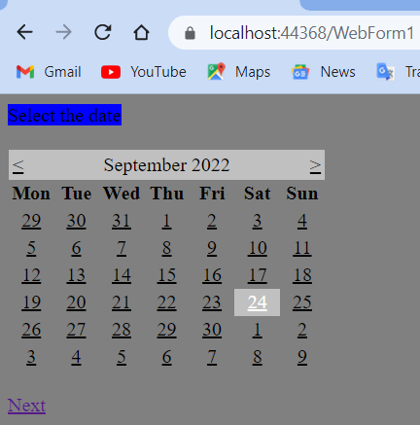

**Aim:**

**c. Create a web application to demonstrate various states of ASP.NET Pages. Code:**

using System;

using System.Collections.Generic; using System.Linq;

using System.Reflection.Emit; using System.Web;

using System.Web.UI;

using System.Web.UI.WebControls;

namespace practical5c

{

public partial class WebForm1 : System.Web.UI.Page

{

protected void Page_Load(object sender, EventArgs e)

{

if(IsPostBack)

{

if (ViewState["count"] != null)

{

int ViewstateVal = Convert.ToInt32(ViewState["count"])+ 1; Label1.Text = "view state :" + ViewstateVal.ToString(); ViewState["count"] = ViewstateVal;

}

else

{

ViewState["count"] = "1";

}

}

}

protected void Button1_Click(object sender, EventArgs e)

{

Label2.Text = ViewState["count"].ToString();

}

protected void Button2_Click(object sender, EventArgs e)

{

if(HiddenField1.Value != null)

{

int val = Convert.ToInt32(HiddenField1.Value) + 1;

HiddenField1.Value = val.ToString();

}

}

protected void Button3_Click(object sender, EventArgs e)

{

HttpCookie h = new HttpCookie("Name"); h.Value = TextBox1.Text; Response.Cookies.Add(h); Response.Redirect("WebForm2.aspx");

}

}

}

**Output:**

